Your Cooking Class
DESIGN YOUR OWN KIDS’ COOKING COURSE
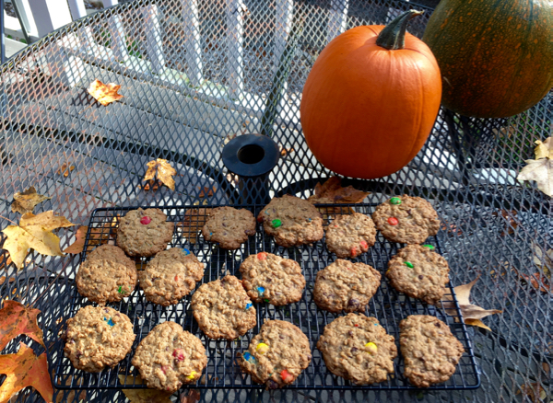

Course Description: Learn how to cook ten different dinners. Become such a great chef that you can do it without any help.

Prerequisite: You may enroll in this class if you want to learn how to cook and if you have completed your baking course.

How: Learn how to prepare all of the items on the list below. Make each recipe once with Mom teaching you, once with Mom there to help as needed, and once all by yourself. Have Mom sign when you have completed each item alone.

When: You may cook once each week – Mom will arrange the schedule with you.

Content: Learn to cook the following ten items. Mom has chosen the first eight dinners, and after successfully learning to make them you may choose items 9 and 10.

Graduation: When you can make all ten dinners on your own without any help, you can plan and prepare your favorite fancy meal for the family. We'll all dress up in our Sunday best to honor your hard work and all you’ve accomplished!

We’ll give you $25 for your savings account, or for you to use to further your education in some way. After you’ve graduated, we will consider you responsible enough to prepare dinner once each week for the family. On the nights you make dinner, you will be excused from clean up.
Your Cooking Class

Dinner Meals | Mom taught me | I made it with  Mom watching | I made it all by myself!
- Pasta and Sauce

- Indian curry with rice
- Pesto Pasta
- Lasagna
- Mexican lasagna
- Tomato soup
- Homemade pizza
- Burritos

